**15 Which configuration would be appropriate for a small business that has the public IP address of 209.165.200.225/30 assigned to the external interface on the router that connects to the Internet?**

**access-list 1 permit 10.0.0.0 0.255.255.255\***  
**ip nat inside source list 1 interface serial 0/0/0 overload\***

access-list 1 permit 10.0.0.0 0.255.255.255  
ip nat pool comp 192.0.2.1 192.0.2.8 netmask 255.255.255.240  
ip nat inside source list 1 pool comp

access-list 1 permit 10.0.0.0 0.255.255.255  
ip nat pool comp 192.0.2.1 192.0.2.8 netmask 255.255.255.240  
ip nat inside source list 1 pool comp overload

access-list 1 permit 10.0.0.0 0.255.255.255  
ip nat pool comp 192.0.2.1 192.0.2.8 netmask 255.255.255.240  
ip nat inside source list 1 pool comp overload  
ip nat inside source static 10.0.0.5 209.165.200.225

**19 What is a characteristic of unique local addresses?**

**They allow sites to be combined without creating any address conflicts.\***  
They are designed to improve the security of IPv6 networks.  
Their implementation depends on ISPs providing the service.  
They are defined in RFC 3927.

**What are two of the required steps to configure PAT? (Choose two.)**

Create a standard access list to define applications that should be translated.  
**Identify the inside interface.\***  
Define the range of source ports to be used.  
Define the hello and interval timers to match the adjacent neighbor router.  
**Define a pool of global addresses to be used for overload translation.\***

**24**

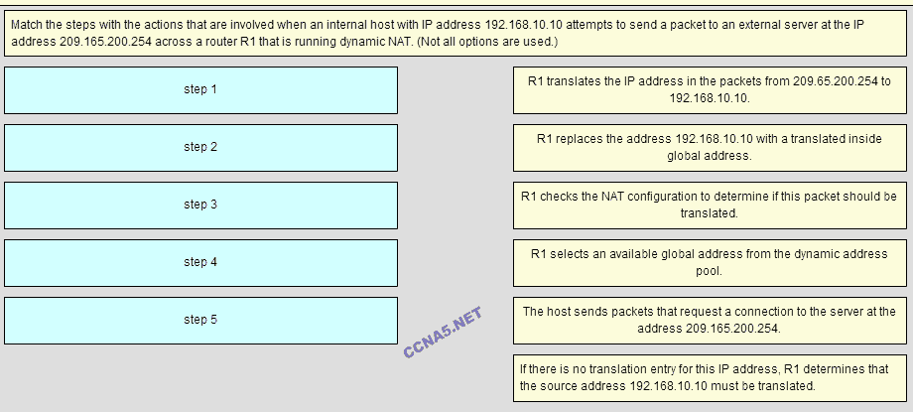

**Place the options in the following order:**   
**– not scored –**   
**step 5**   
**step 2**   
**step 4**   
**step 1**   
**step 3**